**TABLE OF CONTENTS**

**CHAPTER NO. TITLE PAGE NO.**

**ABSTRACT i**

**1. INTRODUCTION 1**

1.1 MOTIVATION 2

1.2 OBJECTIVE 2

1.3 OUTCOMES 3

**2. LITERATURE SURVEY 4**

**3. EXISTING SYSTEM ANALYSIS 8**

3.1 EXISTING SYSTEM EXAMPLE 8

3.2 PRODUCT SCOPE 9

**4. PROPOSED SYSTEM 10**

4.1 SYSTEM ARCHITECTURE 10

4.2 DESCRIPTION 11

4.3 REQUIREMENTS 13

4.4 MODULE DESCRIPTION 16

**5. CONCLUSION 18**

**SCREEN SHOTS 19**

**REFERENCES 30**

**ABSTRACT**

Music is an important entertainment medium. With advancement of technology, the optimization of manual work has gained a lot of attention. Currently, there are many traditional music players that require songs to be manually selected and organized. User, have to create and update play-list for each mood, which is time consuming. Some of the music players have advanced features like providing lyrics and recommending similar songs based on the singer or genre. Although some of these features are enjoyable for user, there is room to improve in the field of automation when it comes to music players. Selecting songs automatically and organizing these based on the user’s mood gives user’s a better experience.

This can be accomplished through the system reacting to the user’s emotion, saving time that would have been spent entering information manually. The Mood Music Player provides a better platform to all the music listeners, and ensures automation of song selection and periodic updating of play-lists. This helps users organize and play songs based on their moods. The player should also give recommendation for users to change songs on-the-go. It helps users to have more customized and organized play-lists.

Continuous music play requires creating and managing personalized song playlist which is a time consuming task. It would be very helpful if the music player itself selects a song according to the current mood of the user. The mood of the user can be detected by a series of questions for which the user should answer.Depending upon the answer given by the user the songs will be played.

**CHAPTER 1**

**INTRODUCTION**

Music listeners have tough time creating and segregating the play-list manually when they have hundreds of songs. It is also difficult to keep track of all the songs, sometimes songs that are added and never used, wasting a lot of device memory and forcing the user to find and delete songs manually. Users have to manually select songs every time based on interest and mood. Users also have difficulty to re-organize and playing music when play-style varies. Currently in existing application, music is organized using play-list where play-list songs cannot be modified or altered in one click. Users have to manually change or update each song in their play-list every time. The sequence of songs in a play-list might not be the same every time, and songs that a user wants to listen frequently might not be given priority or might be left out from the list. Currently, there are no applications that allows users to play songs on-the-go without selecting songs manually or from a play-list.

In music classification stage the predicted mood of the user is used to classify songs and to create a playlist for the particular mood. Songs are categorized into three groups representing the previously specified mood. This classification of songs happens on the basis of genre of the songs. For experimentation some songs are considered which were freely available to download and use. These songs were manually categorized into above said three groups.

**1.1 MOTIVATION**

As a music lover, many felt that music players should do far more things than just playing songs and allowing users to create play-lists. A music player should be intelligent and act according to user’s preferences. A music player should help users organize and play the songs automatically without putting much effort into selection and re-organization of songs. The Mood Music Player provides a better platform to all the music listeners, and ensures automation of song selection and periodic updating of play-lists. This helps users organize and play songs based on their moods. The player should also give recommendation for users to change songs on-the-go. It helps users to have more customized and organized play-lists.

**1.2 OBJECTIVE**

The objective of this application is to solve the basic needs of music listeners without troubling them as existing applications do, it uses various technologies and software’s to increase the interaction of the system with the user in many ways. It eases the work of the end-user by getting their feedback and determining their emotion, and suggesting a customized play-list through a more advanced and interactive system. Feedback based Music Player is interactive, sophisticated and innovative software which is used as a music player in a different manner. The application works in a different manner from the traditional software as it analyses and predicts the perfect song as per the user’s feedback according to the predefined parameters present on the software in order to play a song from the playlist.

**1.3 OUTCOMES**

The outcomes of the proposed work are

* Mood music player provides a log in feature for existing user and a registration feature for the new user
  + Once the user logs into the software, it is directed to the main window.
  + The main window consists of various questions and the user have to select a particular option depending upon their mood.
  + On the basis of the answer provided by the user the music is played which can be controlled by various buttons like play, pause, replay, resume, stop, volume up and volume down.
  + Favorite playlists can also be created and the songs can be removed later for user convenience

The key difference between many other intelligent music players and our music player is the form of input it takes. Other music players need either an image of user or voice of user to recognize mood. The major problem with these systems is that they require a lot of input from user i.e. user needs to waste more time for giving input which may make using them dreary. But, our system can recognize mood of user by analyzing the answers provided by them. Thus, little interaction with user can also provide desired results.

**CHAPTER- 2**

**LITERATURE SURVEY**

Music is an important entertainment medium. With advancement of technology, the optimization of manual work has gained a lot of attention. Currently, there are many traditional music players that require songs to be manually selected and organized. User, have to create and update play-list for each mood, which is time consuming. Some of the music players have advanced features like providing lyrics and recommending similar songs based on the singer or genre. Although some of these features are enjoyable for user, there is room to improve in the field of automation when it comes to music players.

Selecting songs automatically and organizing these based on the user’s mood gives user’s a better experience. This can be accomplished through the system reacting to the user’s emotion, saving time that would have been spent entering information manually. Emotions can be expressed through gestures, speech, facial expressions, etc. For the system to understand a user’s mood, we use facial expression, feedback, voice frequency detection and etc.

The music in a way helps to derive the emotional mood of an individual as songs depict emotions i.e. they are meaningful words arranged in a sequence to convey thoughts or messages to others. The clinical as well as the non-clinical studies, all demonstrate the effective use of music as self-regulative tool for emotions.

Regardless of the difference between the study designs, using active music making and listening versus reflective and non-experimental use of music, all studies revealed the individual applications of music for personal employ, promoting self-regulative skills for positive reconciliation, which are culturally differentiate between all tested societies. These implementations brace the general agreement of this review that music listening is most frequently used with a large range of goals and strategies for emotional regulation purposes

The paper by Hafeez Kabini et al [2] suggested the problem of the existing methods to handle only deliberately displayed and exaggerated expressions of prototypical emotions despite the fact that deliberate behavior differs in visual appearance, audio profile, and timing from spontaneously occurring behavior, by taking efforts to develop algorithms that can process naturally occurring human affective behavior have recently emerged. They also introduced and researched these recent information and discussed human emotion perception from a psychological perspective.

Nikhil Zaware et al [3] stated that it is very time consuming and lengthy task to create and manage large playlists and to select songs from such playlists. Therefore, it would be of great use if the music player itself selects a song according to the current mood of the user using an application to minimize the efforts of managing playlists. In their paper, they stated a way to detect the mood of the user automatically and generate playlist of songs which is suitable for the user’s current mood.

Music is often described as a „language of emotions‟ throughout the globe. Let it be a 80 year old man or a 12 year old girl, everyone has their taste and liking towards a type of music. Hard hitting evidence on why human brain reacts to music differently is not available but scientists have discovered some findings which state that the brain through cerebellum activation synchronizes the pulse of music with the neural oscillators. While processing music brain‟s language centre, emotional centre and memory centre are connected thereby stimulating a thrill obtained by expected beats in a pattern to provide a synesthetic experience [4].

**2.1 ORIGIN OF CONCEPT**

Music and its use for emotion regulation processes, still remains an unanswered question. Many experimental layouts encompassing its daily life use and clinical applications across different cultures and continents have preserved music as a self-regulative tool. Music intervention and emotion regulation measures were viewed and included only when at least forms of music participation (singing, playing, listening, and engagement) were noted in the study and effects on emotion regulation were directly measured. The interrelations between the effects of music on emotion regulation and the use of it as a purposeful instrument, e.g. educational or therapeutic functions, yielded limited results, music interventions for specific.

As some emotion expressions are culturally independent-even in a foreign language where we do not understand the meaning of words it is relatively easy for anyone to recognize surprise, scare, anger, etc. in the message. Also in the depiction of our face expressions it is not so important if we grew up in USA, Britain or China, most of such expressions are very similar and have a similar meaning. The problem arises with text documents. Any sentence or document is strongly dependent on the language it was written in. Also similar languages have often different spelling and often also a bit different. So, music songs in the recent years have become a popular choice to depict human emotions.

Initially, it was a tedious task to label songs based on the emotions they depict from a collection on large database of songs. But audio and lyrics of songs become ways of extracting the emotions and helped to distinguish the different human emotions. Also, it is known that individuals perceive emotions within music differently. Knowing the many existing approaches for modelling the ambiguities of musical mood, a complete system would need to incorporate some level of individual profiling to adjust its predictions.

Music has a’ regulative capacity of itself’, but is confined as valuable instrument for specific emotion regulation interventions. Emotions can appear in most parts of human-to-human communication and often provide additional information about a message.

**2.3 RELATED WORKS**

Currently, there are no dedicated applications to suggest songs based on emotion of music listeners. There are also very few applications that focus on the user preferences and recommendations, and these are not customizable, like AllMusic. Other applications suggest predefined (not user-specific) song play-lists. Application like mood fuse include features like manual selection of songs, partly shuffle, playlist. Some popular music applications like Saavn, Spotify provide users defined play-lists that needs to be created and updated manually.

All of these applications focus on general categorization rather than specificity to every user. A dedicated application that focuses more on user preferences, priorities and the creation of dynamic play-list is required to optimize the user experience. It should contain user specific play-list generated based on the usage and should be efficient in categorization.

Many widely used Facial expression categorization techniques like Viola and Jones etc., which can be used for initial phase to capture and determine the user’s emotion, but these techniques have high computational requirement. The alternative is to use a cloud-based web service that process computation in the cloud. The current system uses, various packages in python for emotion recognition.Packages helps the application to play the music and for connecting the database.

The application is thus developed in such a way that it can manage content accessed by user and also determine the mood of the user.

Currently, there are many existing music player applications. Some of the interesting applications among them are:

• Saavan and Spotify – These application gives good user accessibility features to play songs and recommends user with other songs of similar genre

• Moodfuse - In this application, user should manually enter mood and genre that wants to be heard and moodfuse recommends the songs-list

• Steromood - User should select his mood manually by selecting the moods from the list and the application plays music from YouTube

**CHAPTER 3**

**3.1 EXISTING SYSTEM EXAMPLE**

Mood Player This app uses face detection and mood recognition to determine the user's mood and based on this, it gives a personalized play list.

The face detection algorithm is based on OpenCV library and the mood detection part will be based on pattern matching. If we know the information which is needed, we use the last.fm database which joins every song with tags that describe it. These implementations are designed in order to generate a playlist according to the user mood’s and offer these functionalities:

1. Set your mood manually: happy/sad

2. Get your mood automatically by analyzing a periodical camera capture (frequency can be set from menu)

3. Set the music tempo, from calm to energetic using stereo mood a mobile or tablet application.

With the click of a button we’ll have a ready-made play list for every time in our life: We can choose our mood from our tags, listen, discover new music, share and tag our emotions in music. This application offers the following functionalities:

* Listen to over 100 mood playlists.
* Share your mood and music with your friends on Facebook and Twitter.
* Tag the songs by mood, helping us to build the mood based playlists.
* Discover new artists through your mood.
* Discover your emotional profile of the week by clicking on "my mood" filter.

**3.2.PRODUCT SCOPE**

Mood Music player is a useful application for music listeners with a smart phone and an Internet connection. The application is accessible by anyone who creates a profile on the system. The application is designed to meet the following needs of the users as described below

1. Creating an account or signing up, signing in

2. Adding songs

3. Removing songs

4. Updating songs

5. Personalized play-list

6. Creating favorite play-list

7. Adding songs to the favorite play-list

8. Deleting songs from favorite play-list

9.Buttons for play, pause and stop

10.Controlling the player using replay, resume, volume up and volume down

**CHAPTER 4**

**PROPOSED SYSTEM**

**4.1 System architecture**

Packages

**Get Answers**                                                                         **Play Music**



Login/Sign up phaseAnalyze PhaseMain PhaseDisplay Phase

**Database**



**Figure 3.1** Workflow of Mood Music Player

**4.2 DESCRIPTION**

The proposed algorithm in this involves an emotion music recommendation system that provides the generation of a customized playlist in accordance to the user‘s emotional state. The proposed system involves three major modules: Emotion extraction module, Audio feature extraction module and an Emotion-Audio recognition module.

Emotion extraction module and Audio feature extraction module are two separate modules and Emotion-Audio recognition module performs the mapping of modules by querying the audio meta-data file. The application also includes the facility of sorting songs based on mp3 file properties so that they can be added into appropriate playlists according to the mood.

The proposed system tries to provide an interactive way for the user to carry out the task of creating a playlist. the working is based on different mechanisms carrying out their function in a pre-defined order to get the desired output. The working can be stated as follows:

The proposed System works by first providing a simple enough interface which prompts the user to scan the memory for audio files when the application is opened. Then after the files are detected, they are scanned for audio features and these features are extracted. Then the extracted feature values are subjected to classification according to the parameters provided. These parameters include a limited set of genre types based on which the audio feature values will be processed. After this, the songs are segregated into different playlists based on the feature extraction process. Hence lists of similar sounding songs or songs belonging to similar genres are generated. Mood music Player aims at scanning and deciphering the information and consequently making a playlist based on the parameters provided.

The proposed model is able to extract user’s feelings and thus detect user’s emotion. The music player in our propound model will then play the songs according to the category of emotion detected. It is aimed to provide a better enjoyment to music lovers in music listening.

The working of the system is to recognize the emotion from textual information and provide a music play list from the music player according to mood of the user. Textual information can be collected from the user when user plays any song from the play list of music player. We then identify lyrics of song and with the help of classification techniques; emotions can be extracted from lyrics of song by emotional keyword and semantic information.

After mood identification system will provide music playlist to the user and according to his /her mood selected song will be played. This system will also ask user if he wants to change the mood and wants another play list.

The database is used for authorization of user name and password for the existing user and also used to add the new registered user name and password into the database. pymysql is used to perform data manipulation operation.It is an interface for connecting to mysql database server from python.The goal of pymysql is to a drop in replacement for MySQLdb .

**4.3 REQUIREMENTS**

**4.3.1 HARDWARE REQUIREMENTS:**

* Processor (CPU) with 2 gigahertz (GHz) frequency or above
* A minimum of 2 GB of RAM
* Monitor Resolution 1024 X 768 or higher
* A minimum of 20 GB of available space on the hard disk
* Internet Connection Broadband (high-speed) Internet connection with a speed of 4 Mbps or higher
* Keyboard and a Microsoft Mouse or some other compatible pointing device
* Sound card
* Speakers or headphones

**4.3.2 SOFTWARE REQUIREMENTS:**

**Eclipse** -is an integrated development environment(IDE) used in computer programming, and is the most widely used Java IDE It contains a base workspace and an extensible plug-in system for customizing the environment.

**Xampp** -is a free and open-source cross-platform web server solution stack package developed by Apache Friends, consisting mainly of the Apache HTTP Server, MariaDB database, and interpreters for scripts written in the PHP and Perl programming languages. Since most actual web server deployments use the same components as XAMPP, it makes transitioning from a local test server to a live server possible.

**Anaconda** - is a free and open-source distribution of the Python and R programming languages for scientific computing (data science, machine learning applications, large-scale data processing, predictive analytics, etc.), that aims to simplify package management and deployment. Package versions are managed by the package management system *conda* The Anaconda distribution is used by over 12 million users and includes more than 1400 popular data-science packages suitable for Windows, Linux, and MacOS.

**Spyder** is an open source cross-platform integrated development environment (IDE) for scientific programming in the Python language. Spyder integrates with a number of packages including  NumPy, SciPy, Matplotlib, pandas, IPython, SymPy and Cython, as well as other open source software

**4.3.2.1 PACKAGES**

**Pygame**

  It is a cross-platform set of Python modules designed for computer graphics and sound libraries designed to be used with the Python programming language. Pygame uses the [Simple DirectMedia Layer](https://en.wikipedia.org/wiki/Simple_DirectMedia_Layer) (SDL) library, with the intention of allowing [real-time](https://en.wikipedia.org/wiki/Real-time_computer_graphics) [computer game](https://en.wikipedia.org/wiki/Computer_game) development without the [low-level](https://en.wikipedia.org/wiki/Low-level_programming_language) mechanics of the [C programming language](https://en.wikipedia.org/wiki/C_(programming_language)) and its derivatives. This is based on the assumption that the most [expensive](https://en.wikipedia.org/wiki/Computationally_expensive) functions inside games, can be abstracted from the [game logic](https://en.wikipedia.org/wiki/Model-view-controller), making it possible to use a [high-level programming language](https://en.wikipedia.org/wiki/High-level_programming_language), such as Python, to structure the game.

Other features that SDL doesn't have include vector math, collision detection, 2d sprite scene graph management, [MIDI](https://en.wikipedia.org/wiki/MIDI) support, camera, pixel array manipulation, transformations, filtering, advanced freetype font support, and drawing.Applications using pygame can run on Android phones and tablets with the use of Pygame Subset for Android.Sound, vibration, keyboard, and accelerometer are supported on Android.

**Pymsql**

This is a database connector for Python, that means it is a library to enable Python programs to talk to a MySQL server. MySQL is an immensely popular RDBMS, and you usually need to talk to it when writing a web application in Python. The defector standard, MySQL dB, is a C extension module that has a reputation of being difficult to compile, especially if you're on a Mac (like I am). Additionally, end-users need to wait for new binaries to be compiled for each new release of Python, and MySQL db will never run on Jython, IronPython, or PyPy (without something like cpyext or IronClad). We also maintain 100% compatibility between Python 2 and Python 3, so all advancements made on the 2.x trunk will be immediately available on Python 3.

**Tkinter**

This is a Python binding to the Tk GUI toolkit. It is the standard Python interface to the Tk GUI toolkit.There are several popular GUI library alternatives available, such as wxPython, PyQt (PySide), Pygame, Pyglet, and PyGTK

**4.4 MODULE DESCRIPTION**

The Mood Music Player needs a user account to store the user preferences. Once the user logs-in and the application loads the required components and the user can start answering to the questions. Once the questions are answered, it returns the emotion to the application. The system is currently designed to recognize four basic emotions: happiness, sadness, anger and disgust. After the emotion is recognized, the system runs to categorize and display the play-list to the user. It considers multiple criteria for segregating and displaying songs to the user. The user can change song details like category and interest level at any time in the application. The system also notifies the user of songs that are infrequently played so that they can change songs or delete the songs if it does not fit in the category.

**4.4.1 User Login and Sign-up screen**

If the user is accessing the software for the first time, they need to register for the application .The user must give valid username and password. All the information is validated and account creation is finished. If the username and password is existing in the database , the software direct the user to the main page. Users cannot create multiple accounts with the same username.

The user should provide a registered username and corresponding password to log-in to the software and the information will be saved on cloud. The application saves the user’s authentication information as the default. The user can log-out of the application any time.

Once the user successfully logs-in to the application, the system loads the player. The user is redirected to an error page if they enter the wrong credentials or if they are non-registered.

**4.4.2 Database creation**

In order to gain high accuracy in correctly predicting the mood, properly training model is a vital step. To have a good trained model giving a dataset which accurately justifies the generalized nature of human is also important. The dataset must consist of mood(happy,sad,neutral) of subject or person with varied user input. If the system recognizes and processes different ethnically differentiating moods with more generic in nature and system can be effective generalized with high performance.

**4.4.3 ANALYSING MOOD**

Once the user logged into the software, questions for analyzing the mood of the user is fetched with help of the questions like “How was your day?”, “How was your food?”,”How was your class?” with multiple options listed like “Good”,”Worst”,”Interesting”.If the questions are answered with the user input ,then the mood of the user is fetched and if the questions are not answered then the pop message is displayed in the screen.

Once the user’s emotion is determined, this whole process runs in the background and will fetch songs, organizes and re displays the play-list to the user. The user can change the song category or interest level at any time in the application and the system keeps track of the data.

**4.4.3 FAVOURITE LIST**

         If the user wished to hear the songs later according to the mood selected currently,the songs can be selected and added to the favourite list which will be stored in the playlist. Song can be added or deleted in the favourite playlist according to the user.Favourite playlist will be stored in the database and if the registered user logged in into the player, recently created playlist will be displayed , that provide user to have a better experience in the software.

**CONCLUSION**

In future MoodyPlayer can be enhanced with the capability of detecting the mood of a group rather than individuals. And can be than effectively use in public places and gatherings. The system with some additional functionality can act as a mood lifter or mood enhancer. The software is able to effectively categorize the songs based on the detected mood.

This project was therefore aimed to provide people with befitting music using mood recognition, saving the time which is required to go into the files and scroll at a never ending list of songs to choose from thereby enhancing user experience.

The Mood Based Music System will be of great advantage to users looking for music based on their mood and emotional behavior. It will help reduce the searching time for music thereby reducing the unnecessary computational time and thereby increasing the overall accuracy and efficiency of the system. Also with its additional features mentioned above, it will be a complete system for music lovers and listeners.

**SCREENSHOTS:**

**Login page**

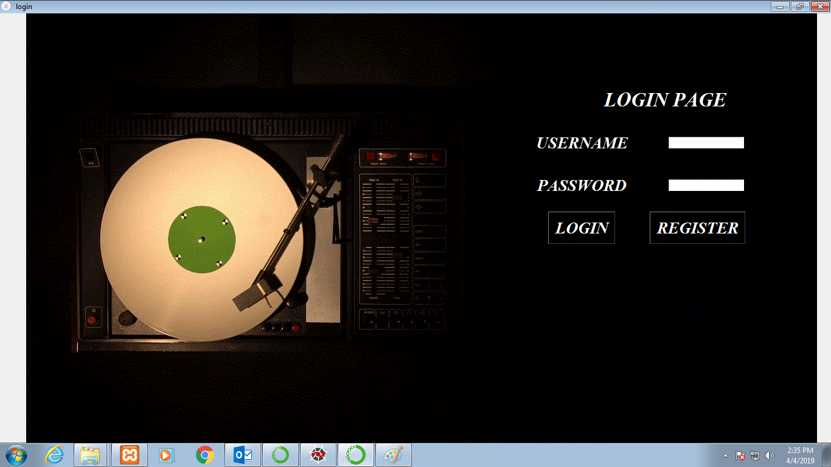

Login page with incorrect user name and password

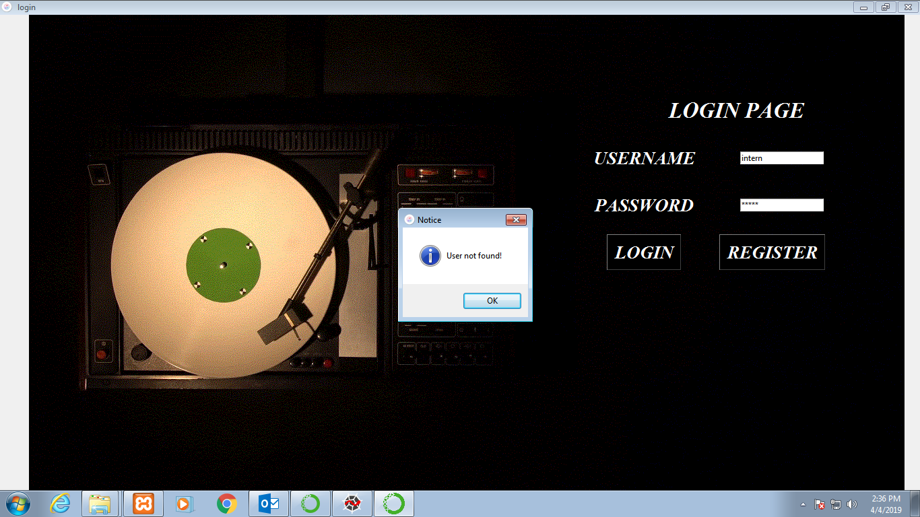

Registration Page

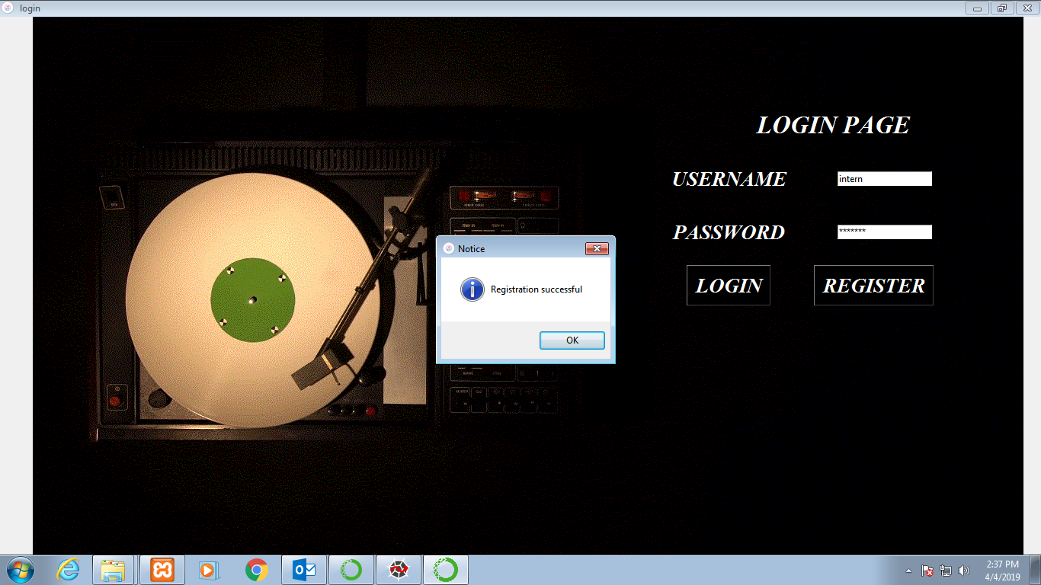

Main Page

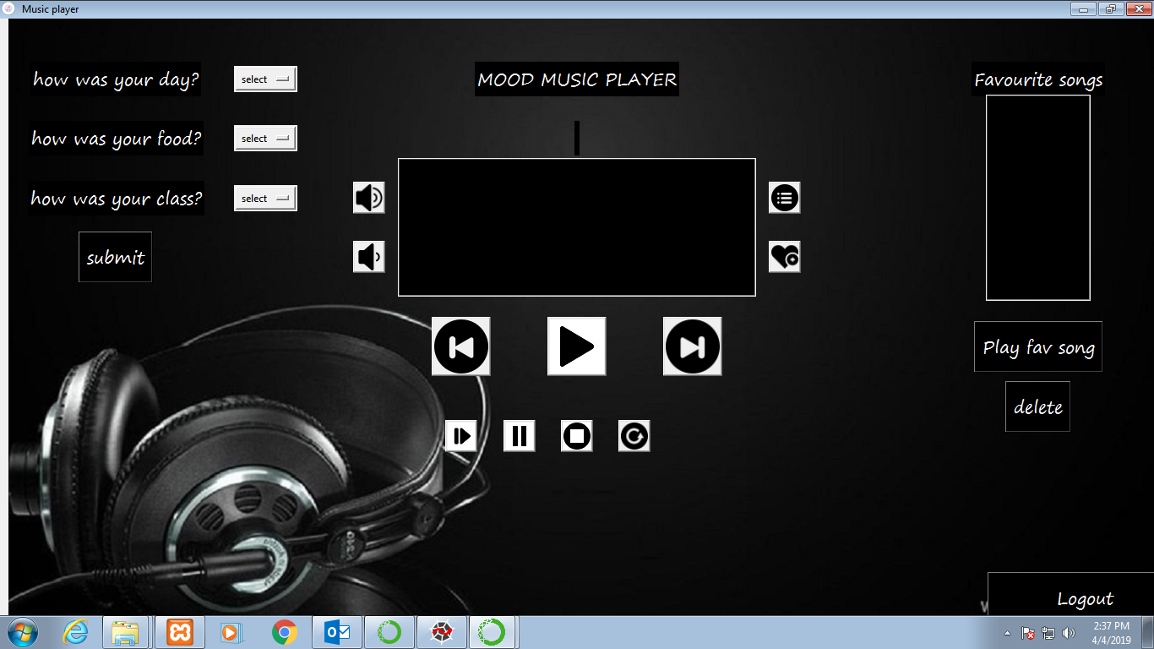

Not answered Main page

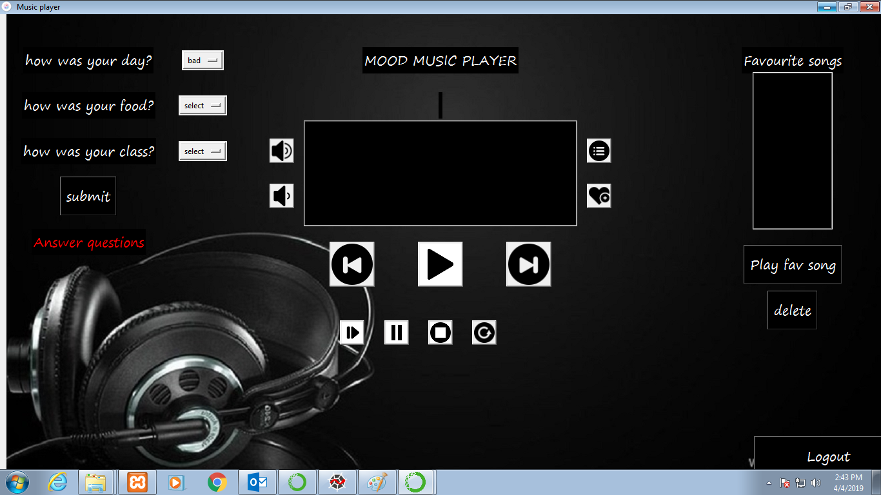

Main Page after selecting the mood

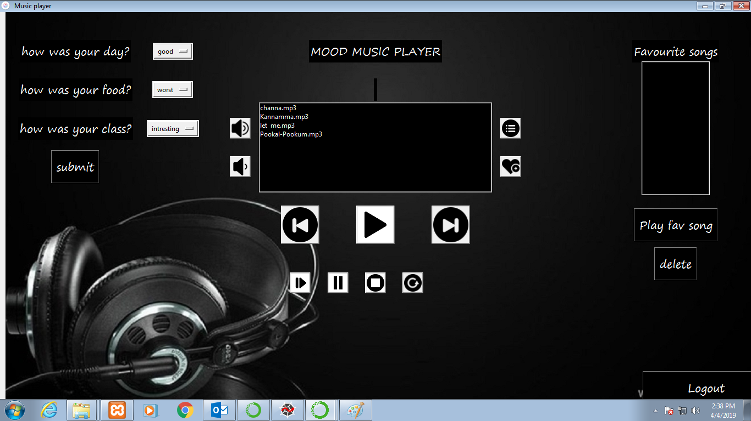

Playing songs according to Mood

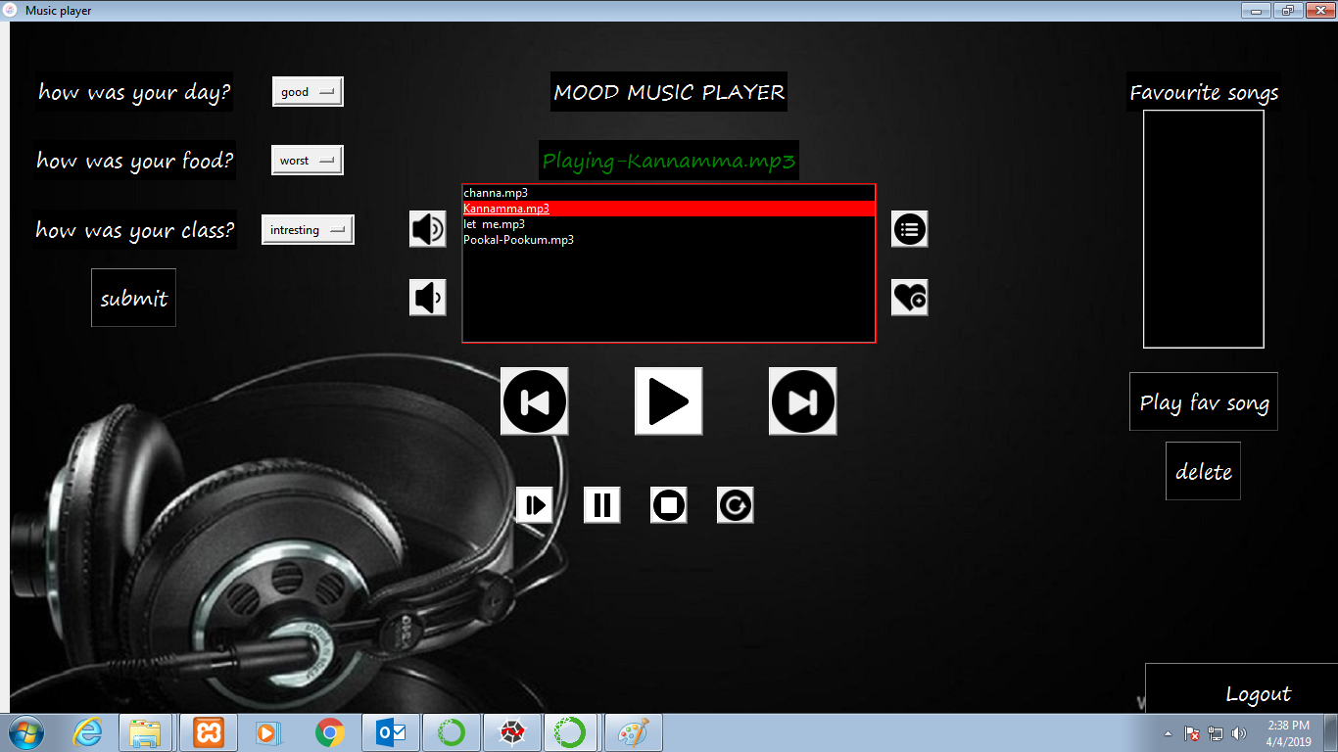

Stop music in the main page

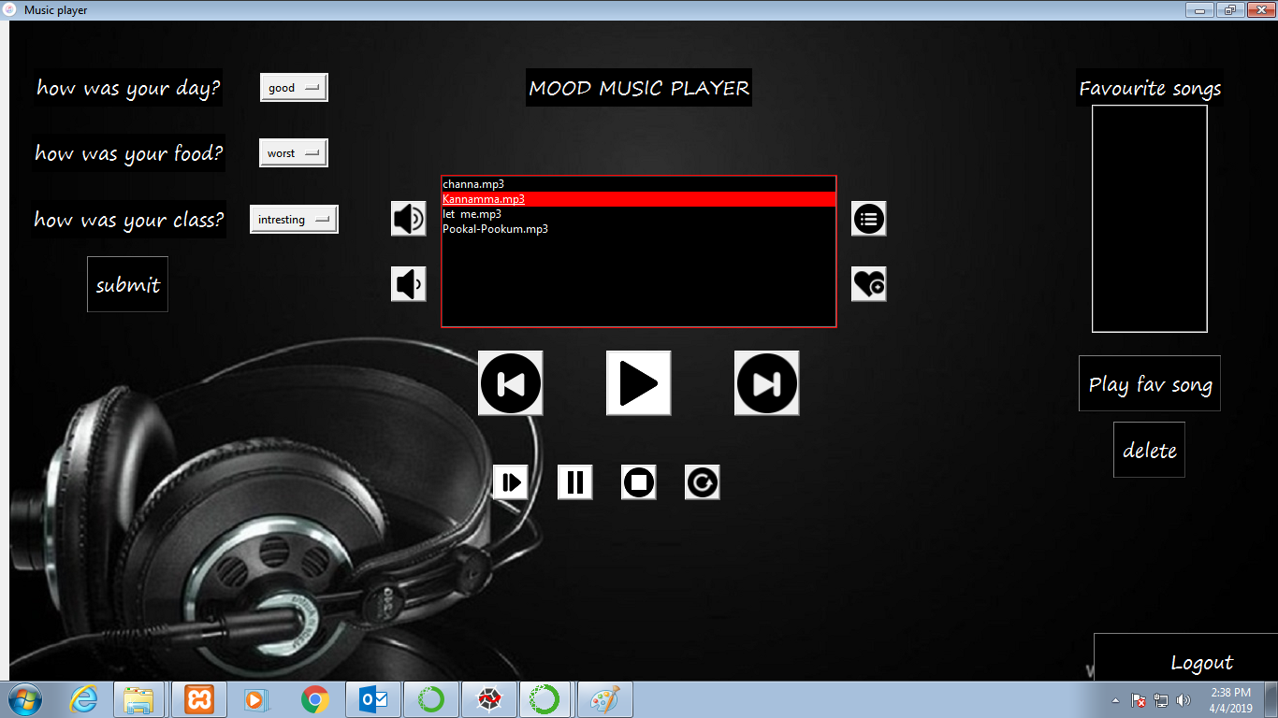

Adding favourite song into the list

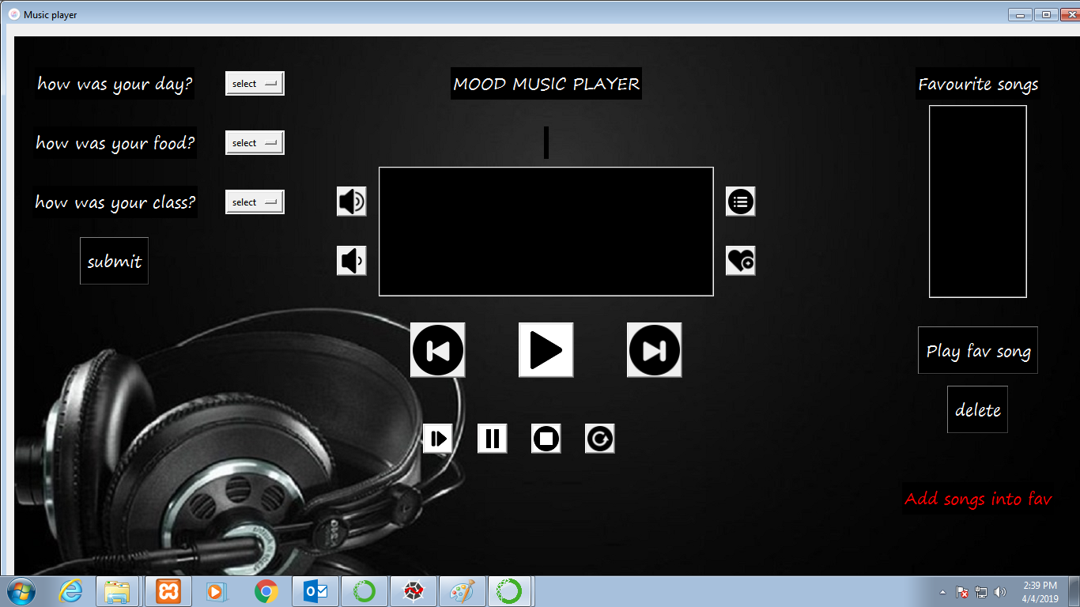

Favourite play list

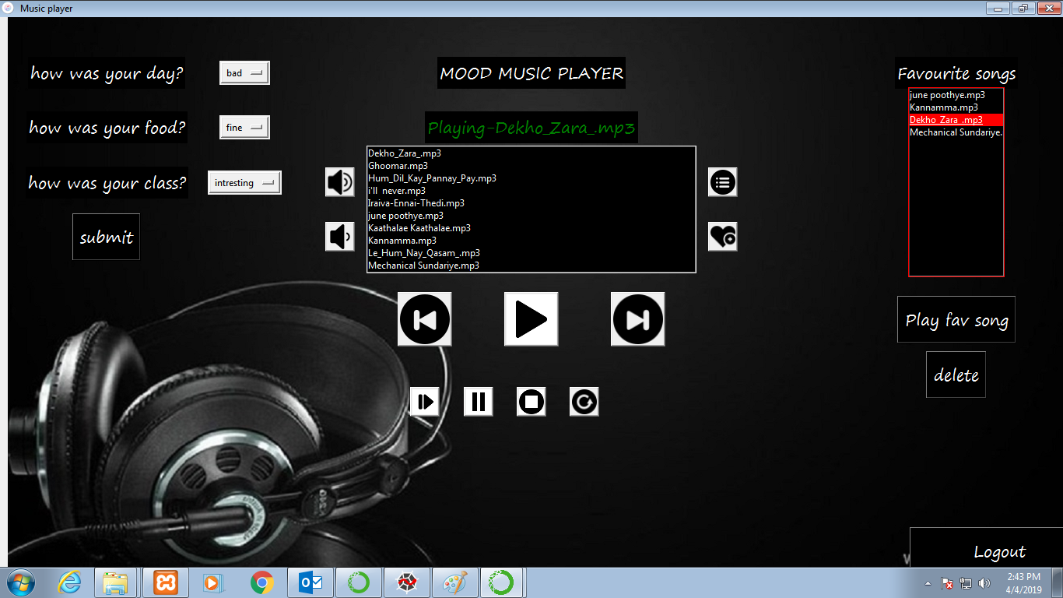

Delete songs from the favourite play list

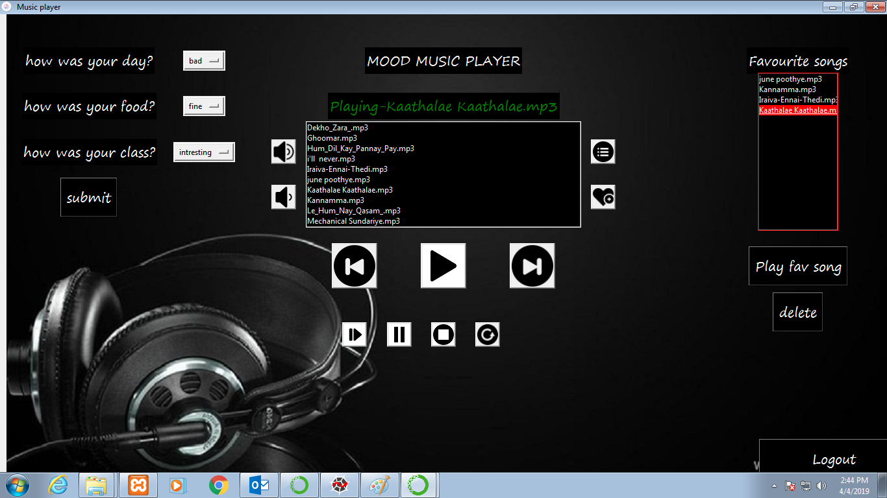

**REFERENCES:**

[1] All music, 2017. [Online; accessed 11-July-2017].

[2] Hafeez Kabini, Sharik Khan, Omar Khan, Shabana Tadvi “EMOTION BASED MUSIC PLAYER” International Journal of Engineering Research and General Science, Volume 3, Issue 1, 2015.

[3] Nikhil Zaware, Tejas Rajgure, Amey Bhadang, D.D. Sakpal“EMOTION BASED MUSIC PLAYER” International Journal of Innovative Research & Development, Volume 3, Issue 3, 2014.

[4] The psychological functions of music listening Christine Städtler and David Huron US National Library of Medicine National Institutes of Health Published online 2013 Aug 13. Prepublished online 2013 May 24.

[5] Melanie Dumas Department of computer science,University of california,san Diego CA 92192- 0114

[6] Emotinal recognition - affectiva, 2017. [Online; accessed 11-July-2017].